**Test Report**

Proposed App Functionality to test:-

1. Set Up of environment(smoke test to verify the build setup)
2. App page is properly opening and fully loaded
3. Add Todo button and text area is enable
4. Metamask can properly connect with App with the added amount
5. Add Todo Text Area can input the value and Add Todo button can be clicked
6. On adding value the same should be shown in Metamask for sign and mine the transaction.
7. Confirmation message should displayed on confirming the transaction
8. The mined transaction should get added at App screen
9. The value of added transaction should get reduced from the account balance
10. Verify the added transaction on page refresh
11. The added value can be remove using Remove Todo button
12. On removing the transaction should be available at Metamask for confirmation
13. On confirmation the transaction should get removed
14. Add the Add Todo with zero amount in the account
15. Add the Add Todo with less amount than the account amount

Issues:-

1. After Add Todo and refresh the page, there is multiple square comes up

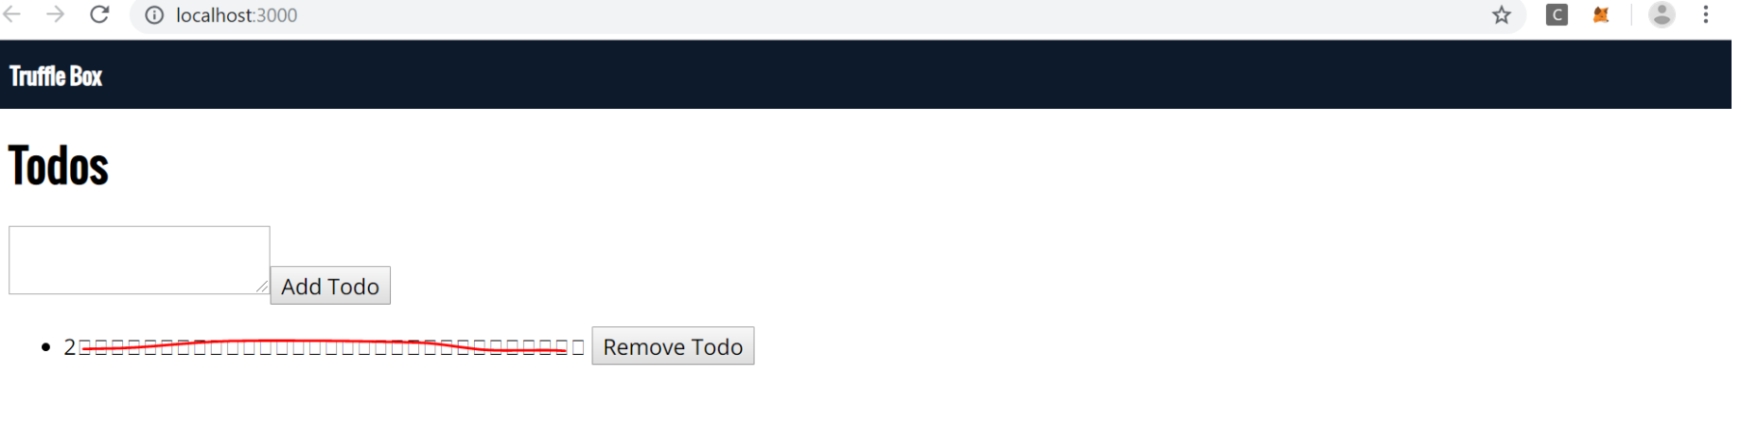

1. On Remove Todo after refresh the multiple square comes up without the value

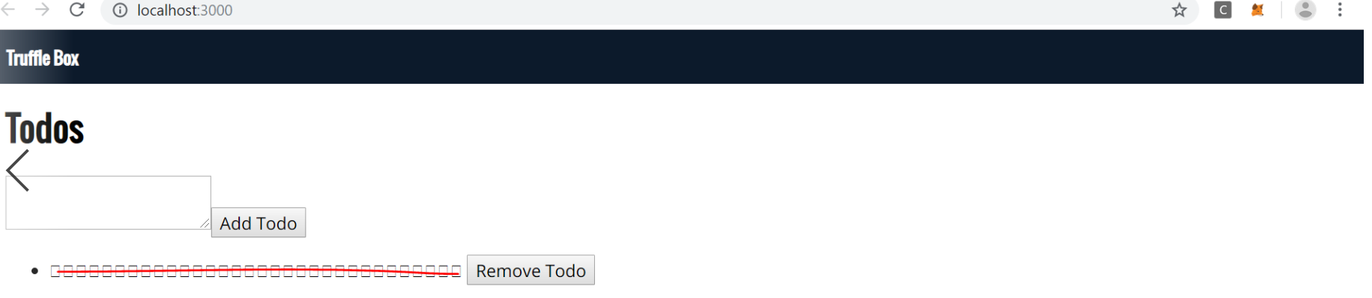

1. On logout and login gain but the Remove Todo still exists
2. On adding multiple transaction and removing leads to multiple lines of square

